**Database Systems**

**Project Report**

Railway Management System

https://apex.oracle.com/pls/apex/r/302/railway-management-system/login?session=10974569220342

# 1. E-R Model of the Project

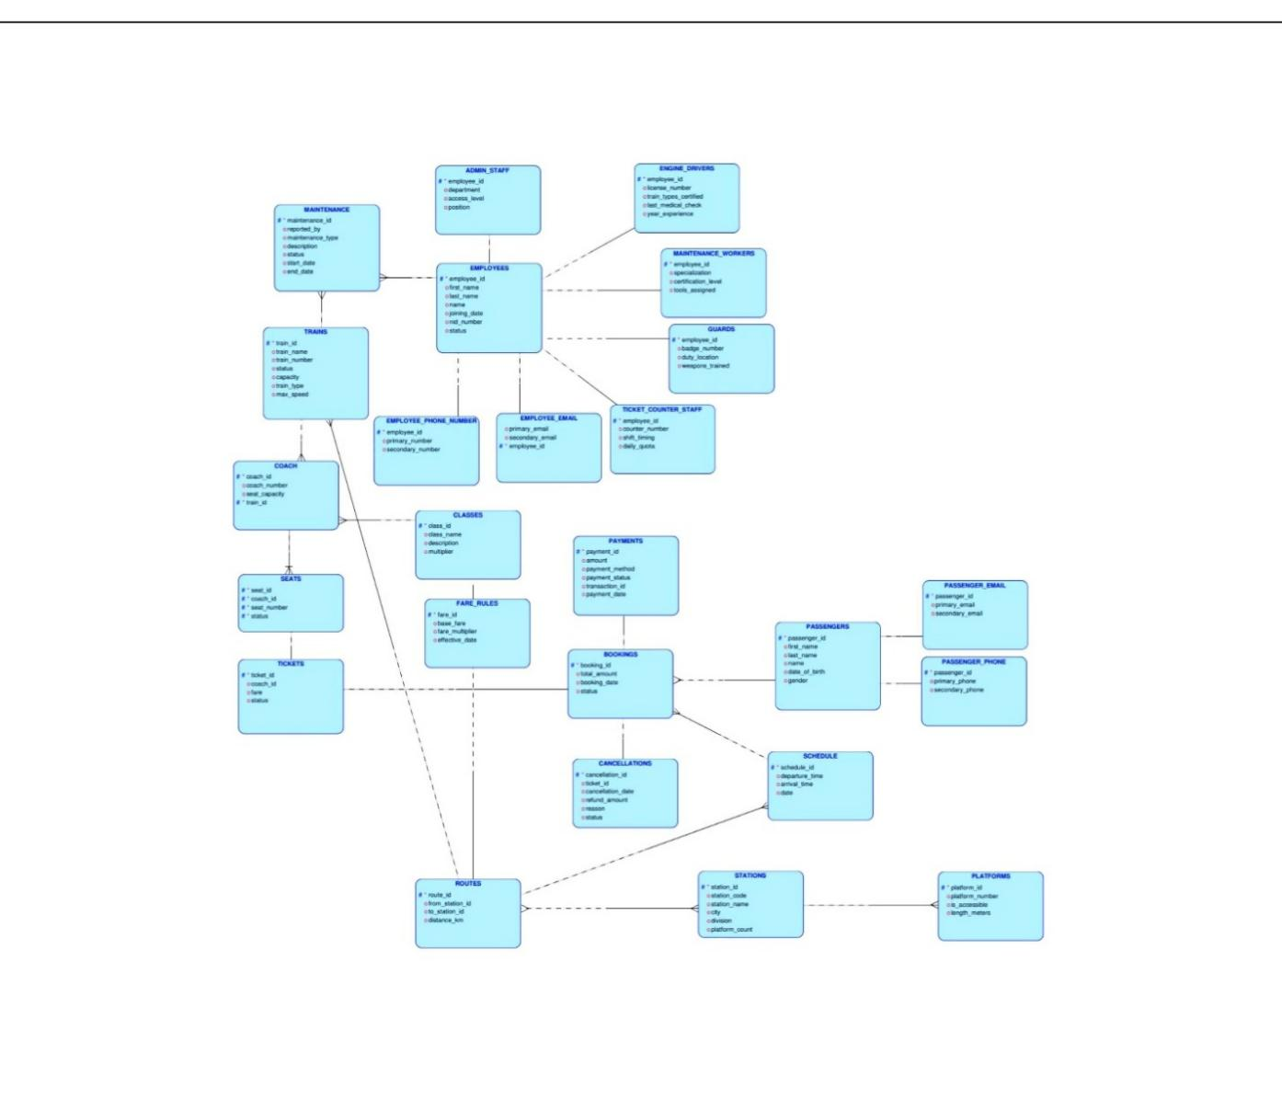

Figure: E-R Diagram of Railway Management System

# 2. Schema Design of the Project

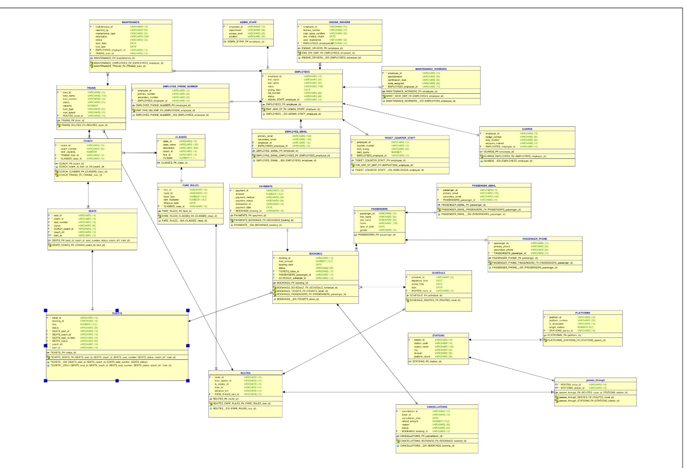 Figure: Schema Diagram of Railway Management System

# 3. Implementation Checklist

|  |  |
| --- | --- |
| Description | Remarks |
| Project ID | 176164 |
| Workspace Name | 302 |
| Workspace Email | mhadorbd247@gmail.com |
| Workspace Password | Ador1234 |
|  |  |
| Authentication Type | Custom |
| Username and Password to Login | Username: Muntasir Pass: mun123 |
| write username like admin | Username: Fokrul Pass: fok123 |
| if you have multiple users, write all username and password correctly | Username: [MHADORBD247@GMAIL.COM](mailto:MHADORBD247@GMAIL.COM)  Pass: Ador1234 |
|  |  |
| Number of Forms | 9 |
| Number of Reports | 3 |
| Number of Reports with Forms | 18 |
| Number of Reports based on Queries, Aggregate Queries | 18 |
|  |  |
| Included any trigger/other feature which is not taught in class. If yes, please explain briefly. | For Authorization, we didn’t show the users any report/form/view that the user shouldn’t see. For user those report/form/view won’t show in navigation menu. |
| Write the most unique feature/functionality in your application or the page of your application that you are proud of. Explain briefly. | We are able to find out every possible information  about ticket where we join all the related table. We can also find out how much revenue each payment method generated. We can also find out how much revenue each train generates. |

Use more rows if necessary.

4. Reports with Forms

|  |  |  |
| --- | --- | --- |
| Report Page Number and  Name | Form Page Number and  Name | Table |
| Page 10: Passenger Details | Page 31: Passenger Form | PASSENGERS |
|  | Page 33: Passenger Phone Form | PASSENGER_PHONE CASCADE |
| Page 68: Schedule Details | Page 35: Schedule Form | SCHEDULE |
| Page 64: Booking Details | Page 37: Booking Form | BOOKINGS |
| Page 46: Ticket Details | Page 39: Ticket Form | TICKETS |
|  | Page 41: Payment Form | PAYMENTS |
|  | Page 43: Cancellation Form | CANCELLATIONS |
|  | Page 45: Maintenance Form | MAINTENANCE |
|  | Page 71: Passenger Email Form | PASSENGER_EMAIL |
| Page 17: Train Details |  | TRAINS |
| Page 2: Station Details |  | STATIONS |
| Page 13: Employee Details |  | EMPLOYEES |
| Page 23: Platform Details |  | PLATFORMS |
| Page 20: Employee Email Details |  | EMPLOYEE_EMAIL |
| Page 21: Route Details |  | ROUTES |
| Page 25: Fare Rules Details |  | FARE_RULESCLASSES |
| Page 36: Employee Phone Details |  | EMPLOYEE_PHONE_NUMBER |
| Page 44: Admin Staff Details |  | ADMIN_STAFF |
| Page 50: Engine Drivers Details |  | ENGINE_DRIVERS |
| Page 52: Maintenance Workers Details |  | MAINTENANCE_WORKERS |
| Page 56: Guard Details |  | GUARDS |
| Page 73: Seat Details |  | SEATS |
| Page 86: User Details |  | Oracle Apex |
| Page 89: Classes Details |  | CLASSES |
| Page 92: Coach Details |  | COACH |
| Page 60: Ticket Counter Staff Details |  | TICKET_COUNTER_STAFF |

Figures 1

Figures 2

Figures 3

Figures 4

Figures 5

Figures 6

Figures 7

Figures 8

Figures 9

Figures 10

Figures 11

Figures 12

Figures 13

Figures 14

Figures 15

Figures 16

Figures 18

Figures 21

Figures 21

Figures 23

Figures 25

Figures 26

Figures 28

Figures 29

Figures 30

Figures 31

Figures 31

Figures 32

# 5. Reports based on Multi-Table and Aggregate Queries

|  |  |  |
| --- | --- | --- |
| Page Number and  Name | Query Type | Report description |
| Page 122: V_Ticket_Info | Multitable | Comprehensive view of all ticket-related information |
| Page 126:V_Revenue_Per_Route | Aggregate + Multitable | Calculates total revenue by route |
| Page 128: V_Class_Wise_Booking | Aggregate + Multitable | Provides ticket sales statistics by class |
| Page 132: V_Cancellation_Info | Multitable | Shows cancelled tickets with refund information |
| Page 136: V_Staff_Count | Aggregate | Counts active staff members by role type |
| Page 138: V_Train_Movement | Multitable | Shows train schedules with station movements |
| Page 30: V_Passenger_Without_Tickets | Multitable | Shows passengers with no ticket history, indicating they never finalized a booking. |
| Page 3: V_Booking_Info | Multitable | Shows complete booking information including passenger and station details |
| Page 108: V_Payment_Details | Multitable | Displays full payment details with passenger and booking information |
| Page 100: V_Maintenance_Details | Multitable | Shows maintenance work details along with employee and train information |
| Page 120: V_Revenue_by_Payment_Method | Aggregate | Calculates total revenue grouped by payment method |
| Page 166: V_Ticket & Rev Count | Aggregate + Multitable | Shows number of tickets sold and total revenue for each train |
| Page 142: V_Employee_Contact | Multitable | Consolidates employee info with their contact numbers and emails |
| Page 146: V_Routes_Stations | Multitable | Displays each route with the names of its origin and destination stationsand distance |
| Page 150: V_Train_Certification | Multitable | Shows which engine drivers are certified for which types of trains |
| Page 152: V_Coach_Train_Class | Multitable | Shows coach details along with associated train and class names |
| Page 9: V_Avg_Fare_By_Class | Aggregate + Multitable | Calculates average fare paid by class of coach |
| Page 160: V_Route_Class_Fare | Multitable | Displays fare structure by route and class, with station names |



Figures 5.126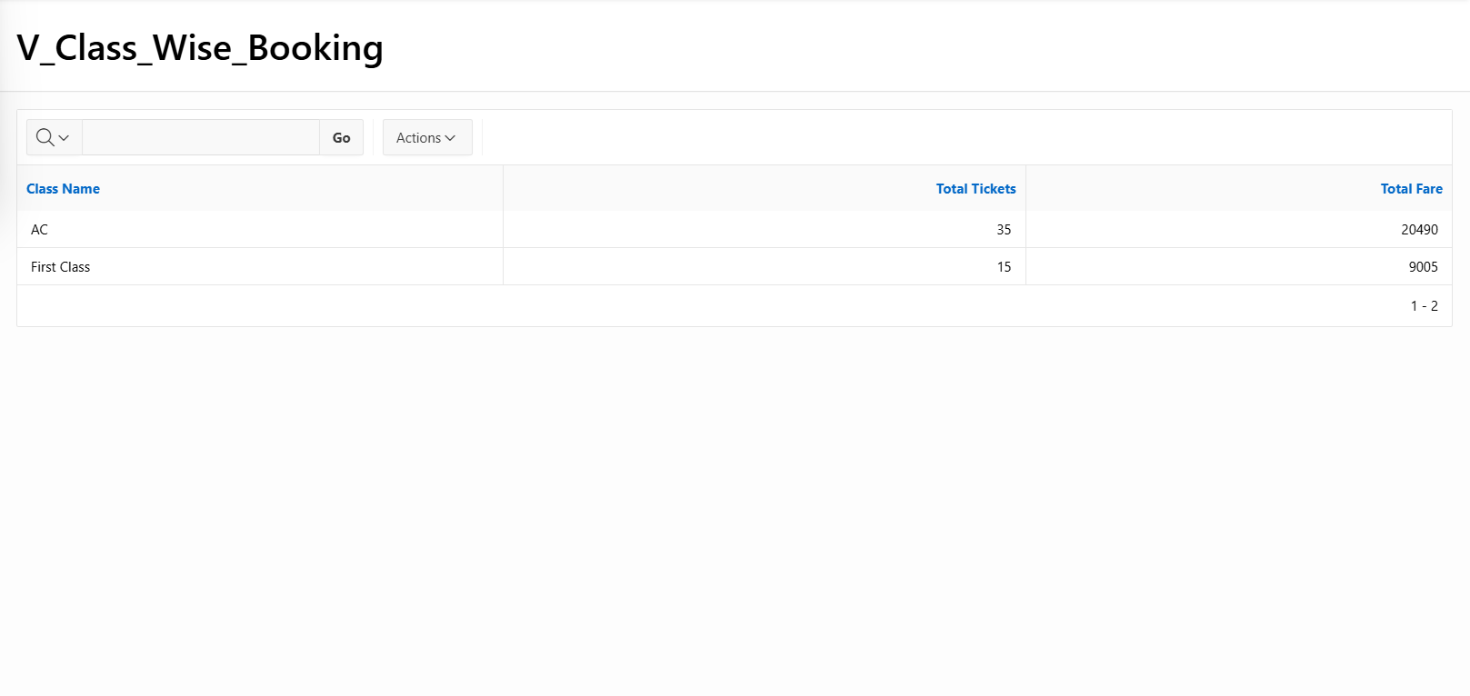

Figures 5.128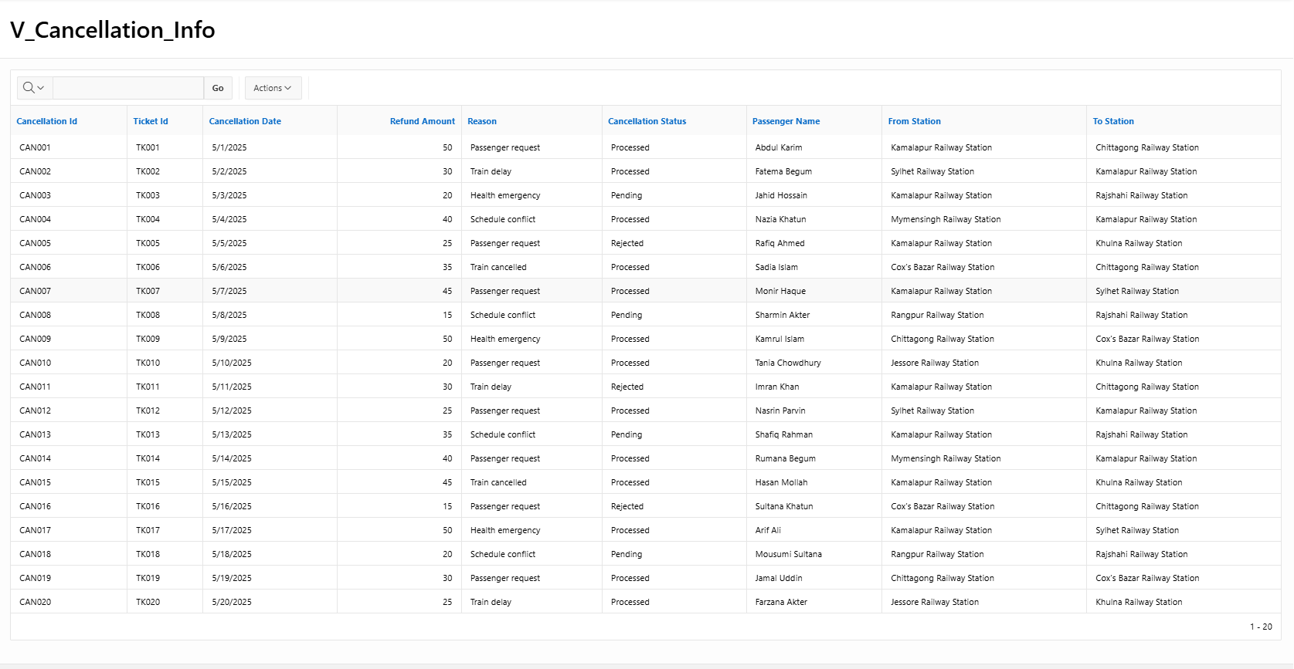  
Figures 5.132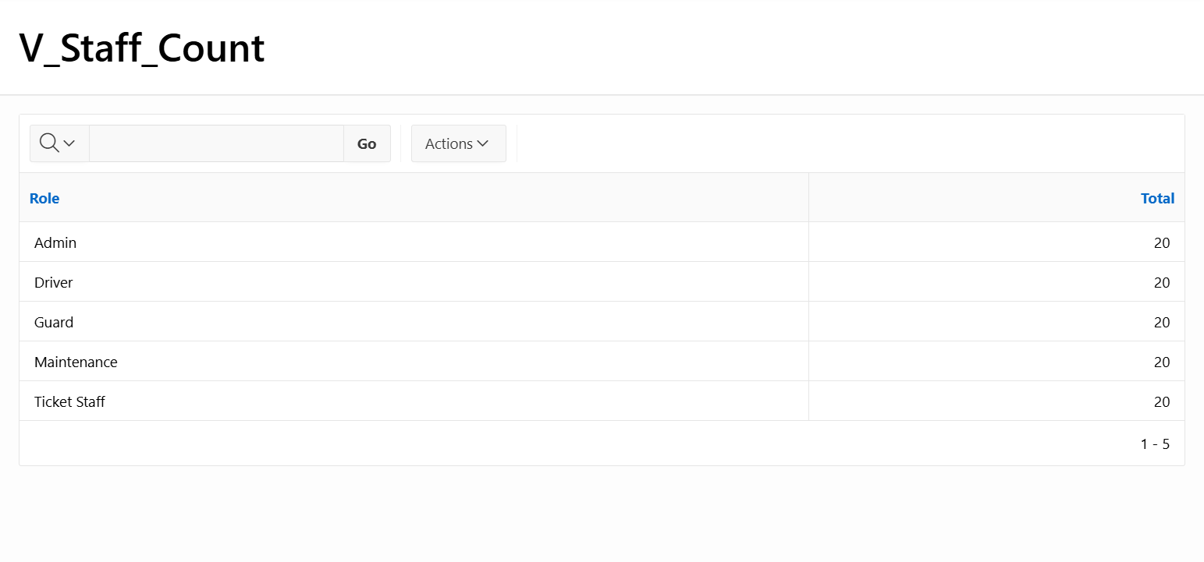  
Figures 5.136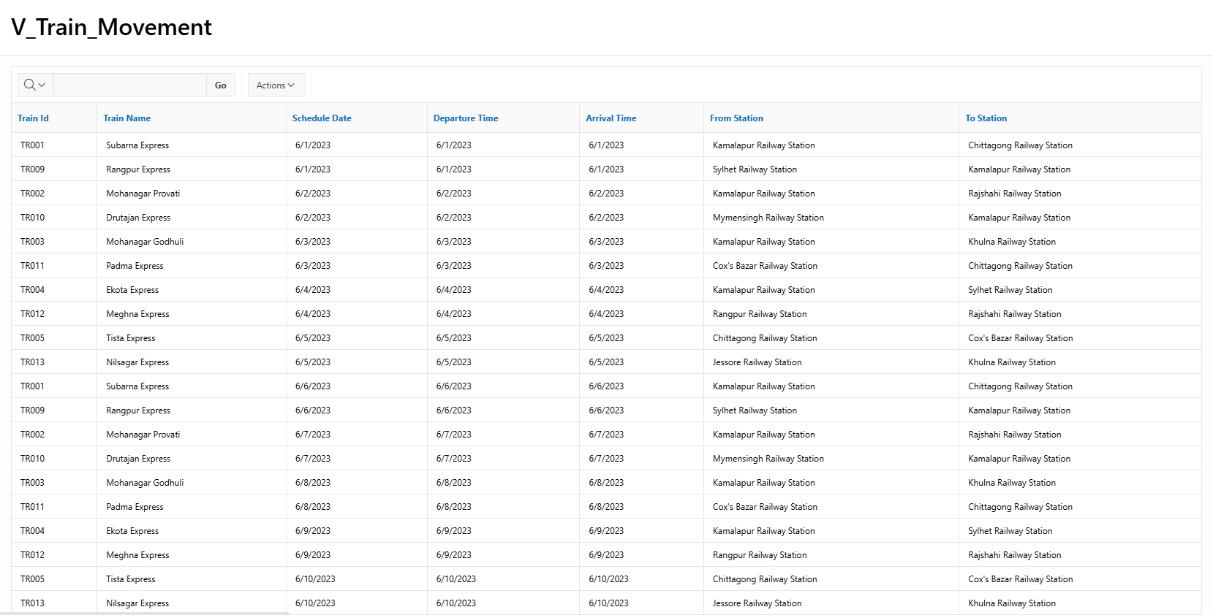  
Figures 5.138

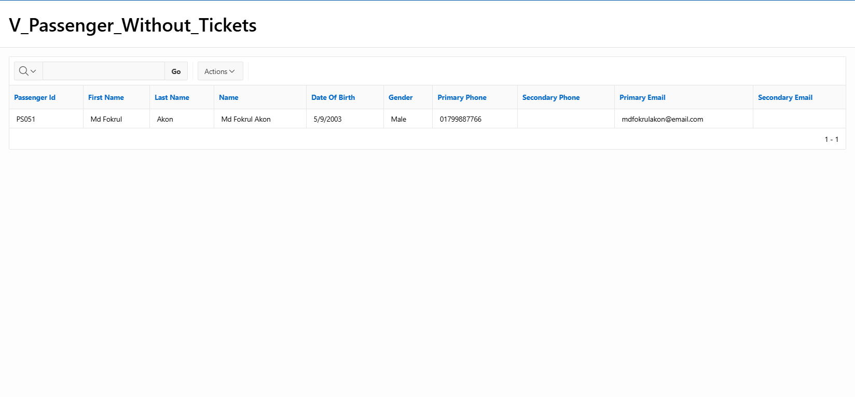  
Figures 5.30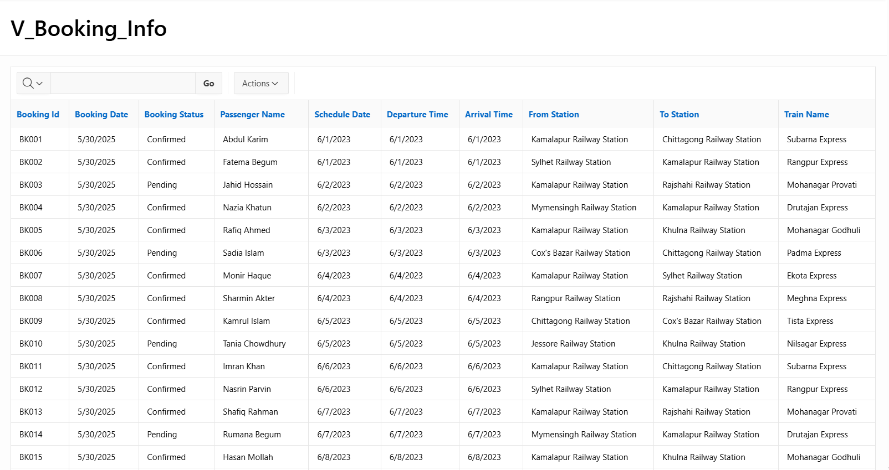  
Figures 5.3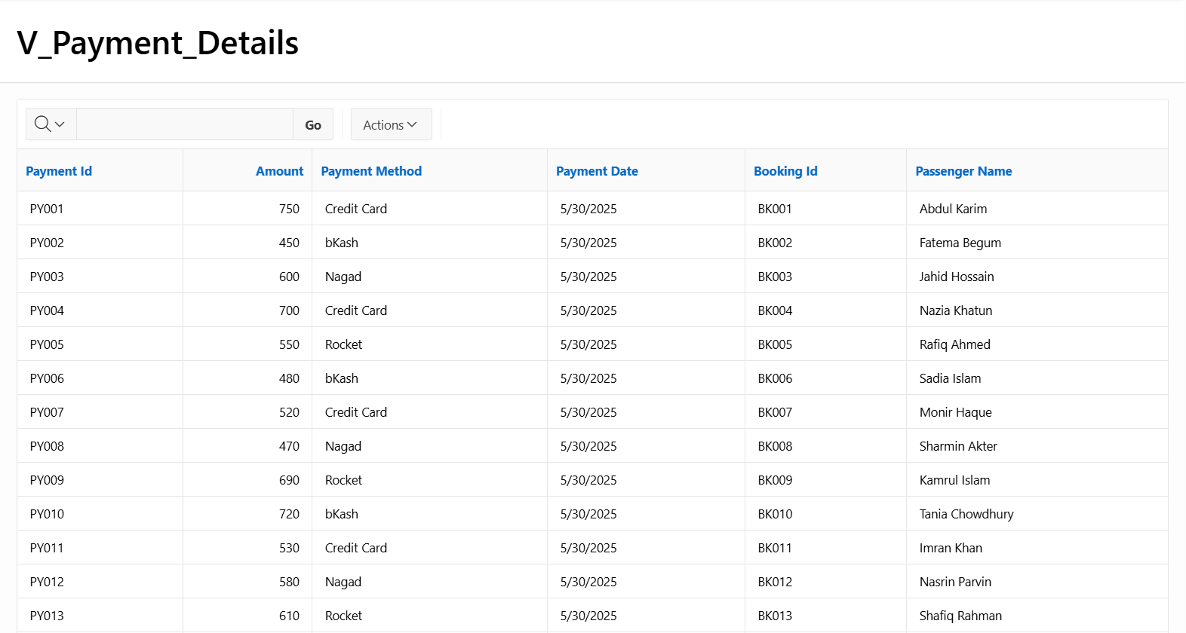  
Figures 5.108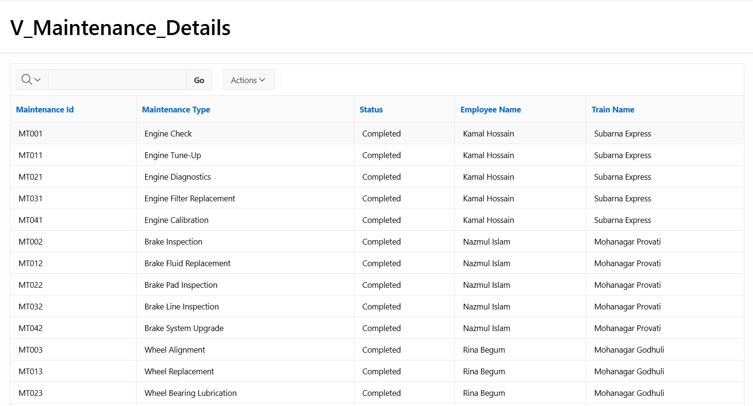  
Figures 5.100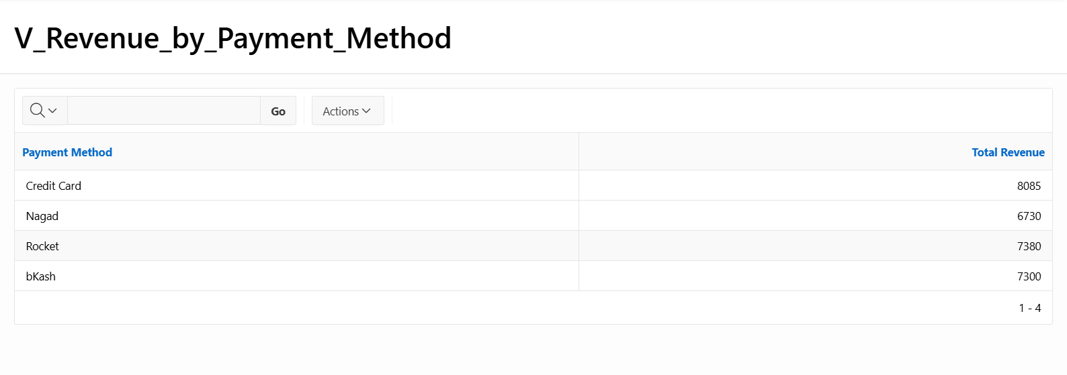

Figures 5.120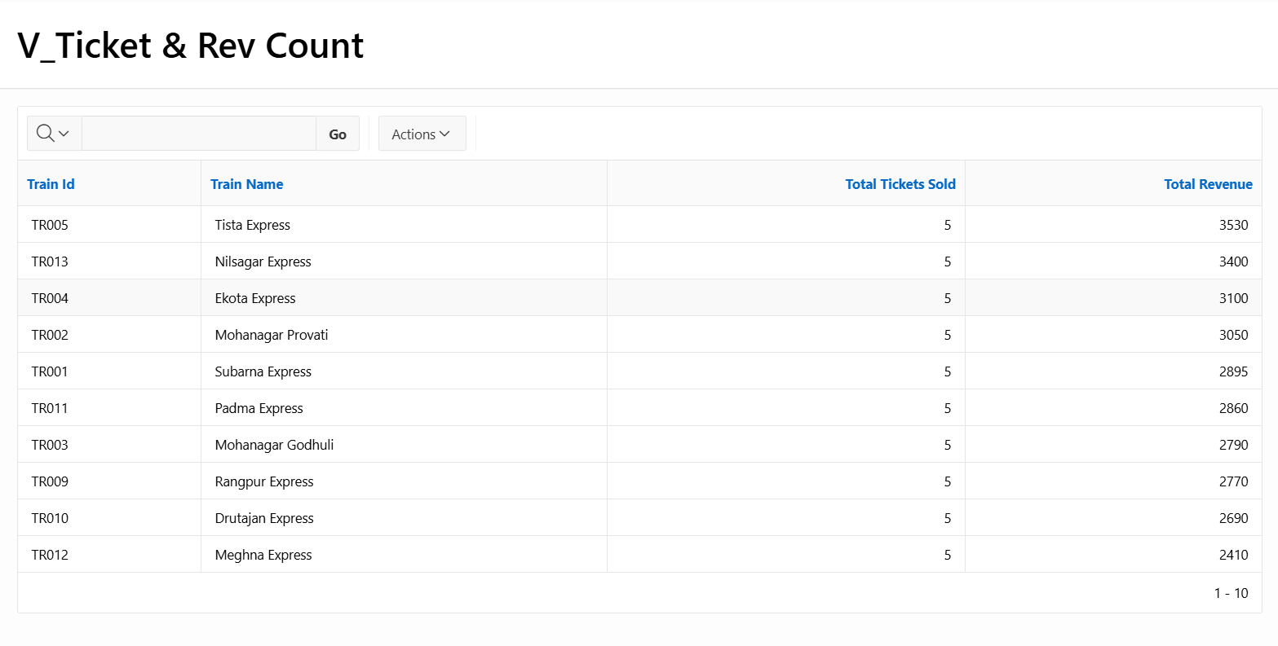  
Figures 5.166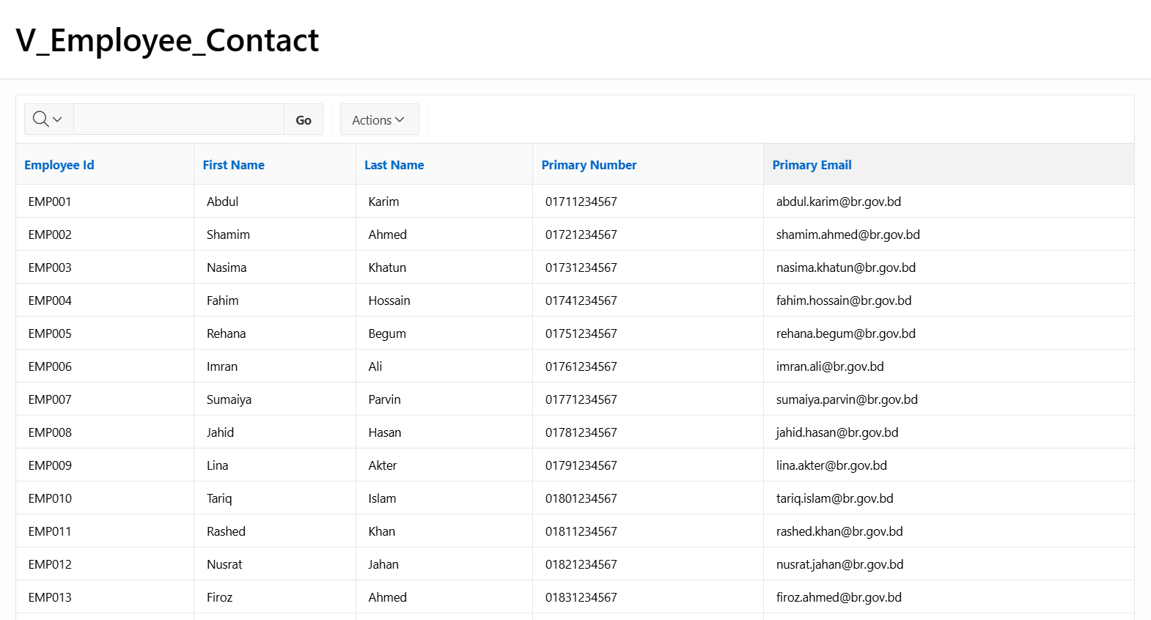

Figures 5.142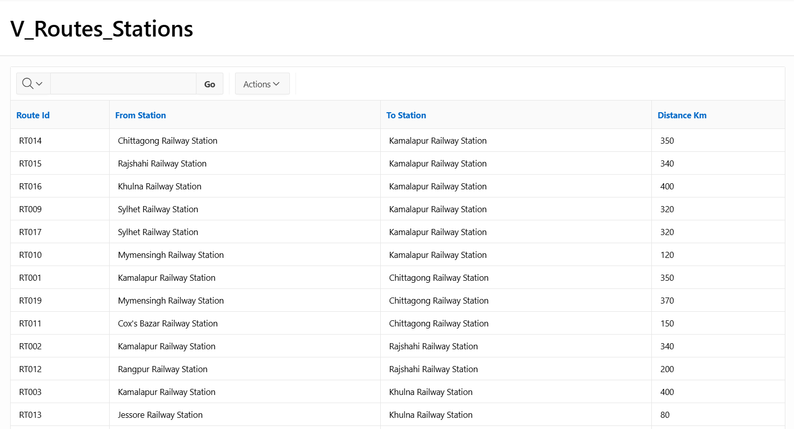

Figures 5.146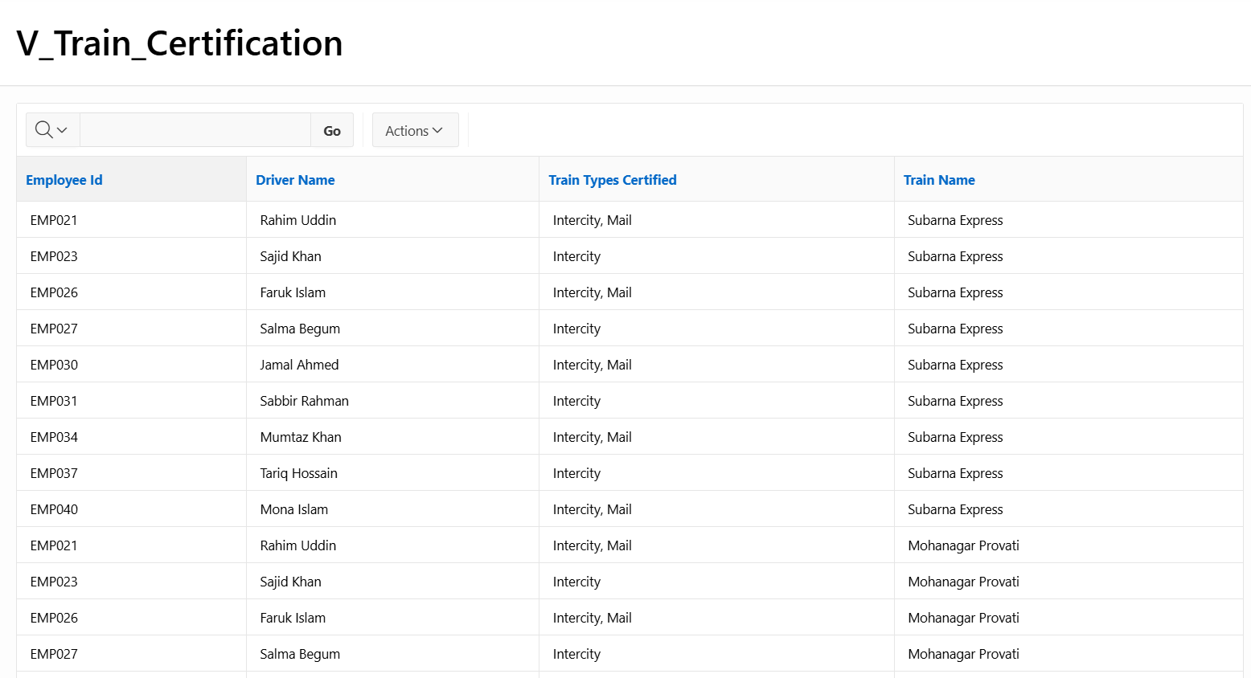

Figures 5.150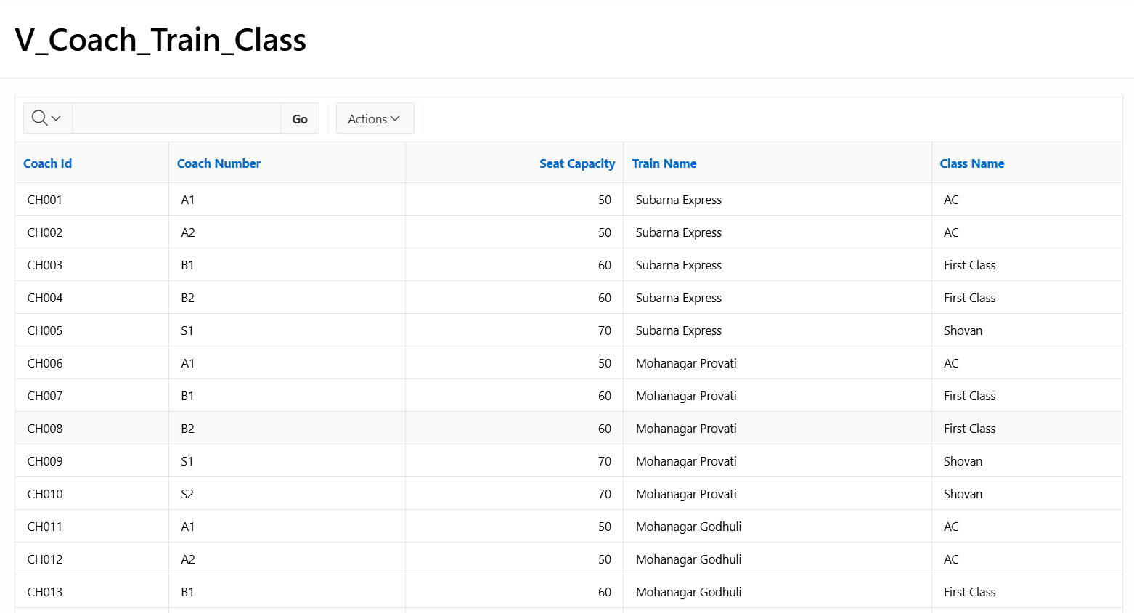

Figures 5.152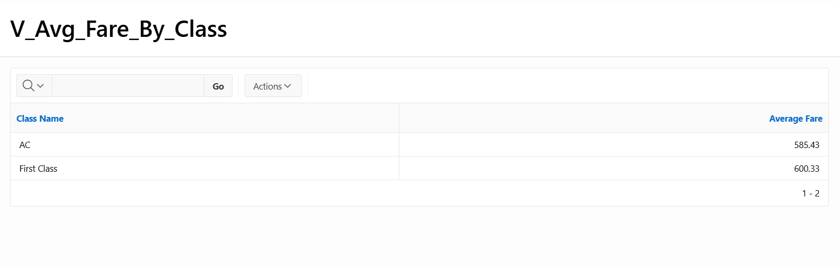

Figures 5.9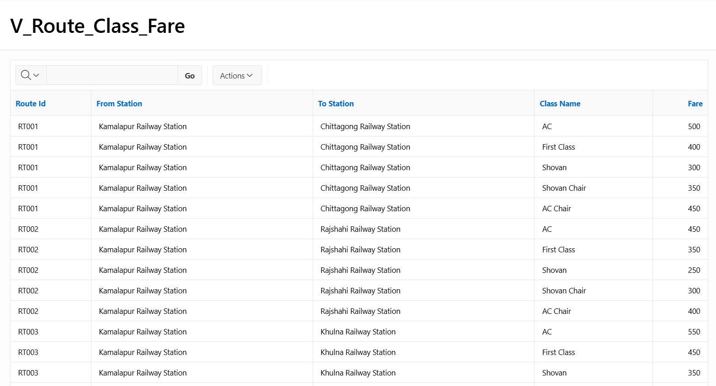  
Figures 5.160

# 6. Authorization and User Role Assignment

**User Role Assignment**

|  |  |  |
| --- | --- | --- |
| User name | Password | Role |
| Muntasir | mun123 | Administrator |
| Fokrul | fok123 | user |
| MHADORBD247@GMAIL.COM | Ador1234 | Administrator |

# 7. Concluding Remarks

During the course of this project, we gained a complete understanding of the ER diagram and schema concept, which greatly enhanced our database design skills. While writing SQL queries, we primarily used simple joins due to our fear of making mistakes. Unfortunately, despite this caution, we still encountered several issues that took considerable time to resolve.

When we uploaded the full code, we encountered an Oracle Apex error indicating that we had exceeded the resource limit. Additionally, we initially faced difficulties in creating the sub-menu due to some persistent errors. Unfortunately, we were unable to resolve that specific issue. Later, we identified an unexpected loop in our SQL code, which, with your kind assistance (MRJ Ma’am), we managed to locate. Solving this issue required us to rewrite all the database tables, which took approximately nine hours.

Due to our limited knowledge of Oracle APEX, we were unable to create a more sophisticated and user-friendly interface. Even changing the background template and adding a logo took around seven hours. Throughout this process, we also learned some basic CSS, which helped us improve the visual aspects of the project.

We thoroughly enjoyed working on this project, Ma’am. Having previously conducted several research projects on railway management systems, we already had a good grasp of how such systems operate, which made the development process smoother. Additionally, this project gave us the opportunity to better understand and clarify many topics from our database course.

Most importantly, this project strengthened our teamwork and collaboration. We worked together closely, built strong bonds among our team members, and turned our project time into a truly rewarding and enjoyable experience.